Centro Educacional Brasil Portugal
Teacher: Márcia Cristine | Subject: English | Class:Pré 2
Name:__________________________________________________

SEMANA de 13 até 17/04
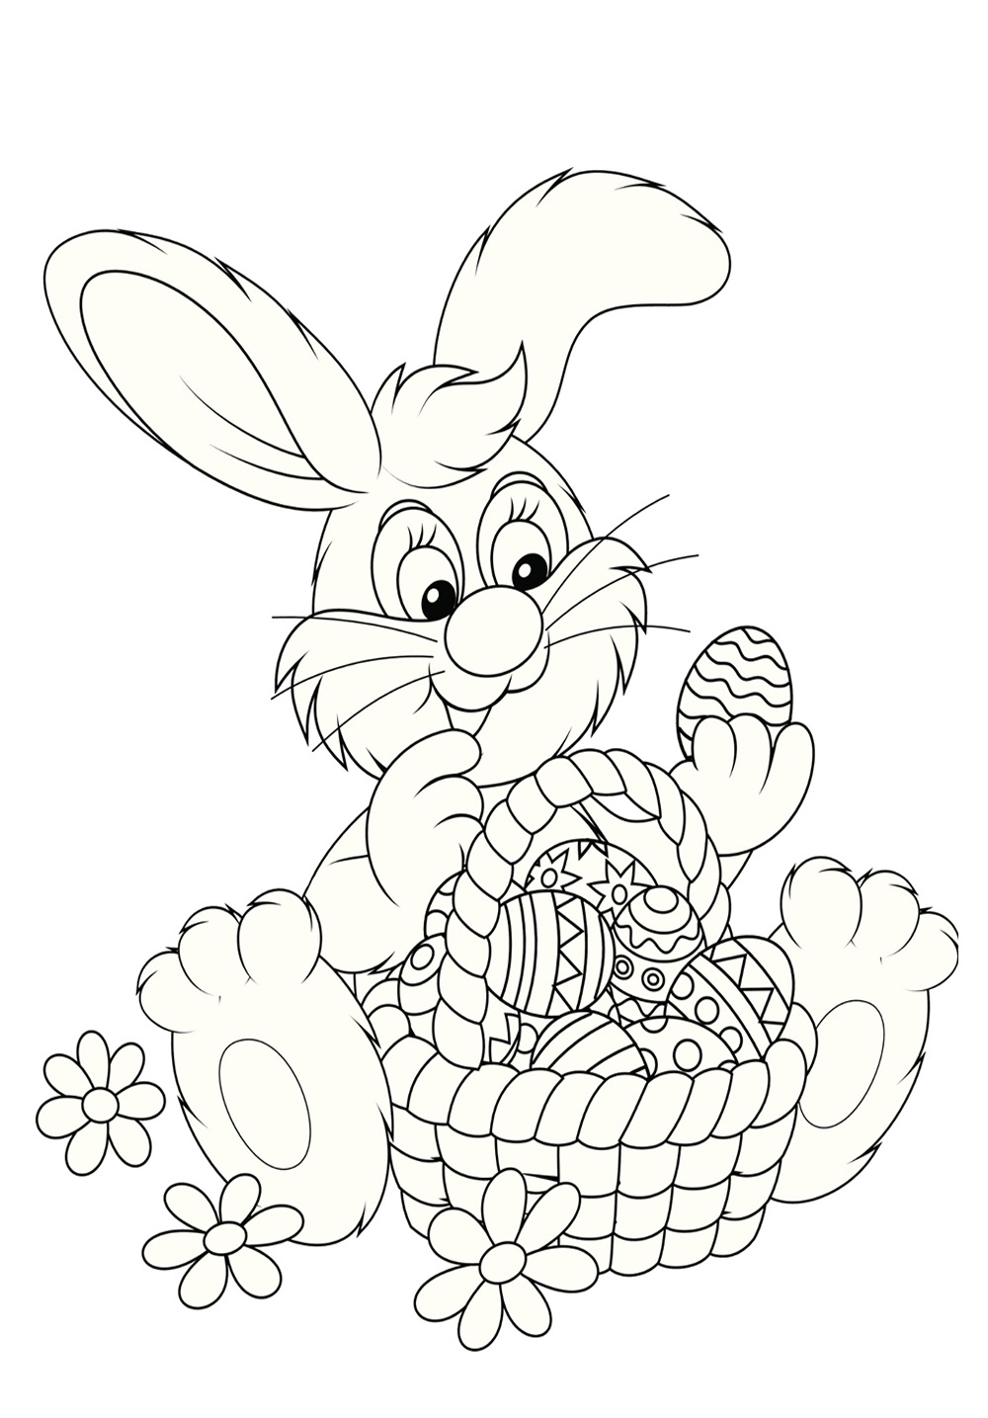
- Let’s color! (Vamos colorir!)

HappyEaster!

